DOCUMENT: DATA FLOW DIAGRAMS & USER STORIES

Phase | Project Design Phase II
Document | Data Flow Diagram & User Stories
Project Name | PetPaws – Pet Foods & Accessories Store
Team ID | [TEAM-ID]
Date | 14 June 2026
Maximum Marks | 4 Marks

Data Flow Diagrams (DFD)

Level 0 DFD — Context Diagram

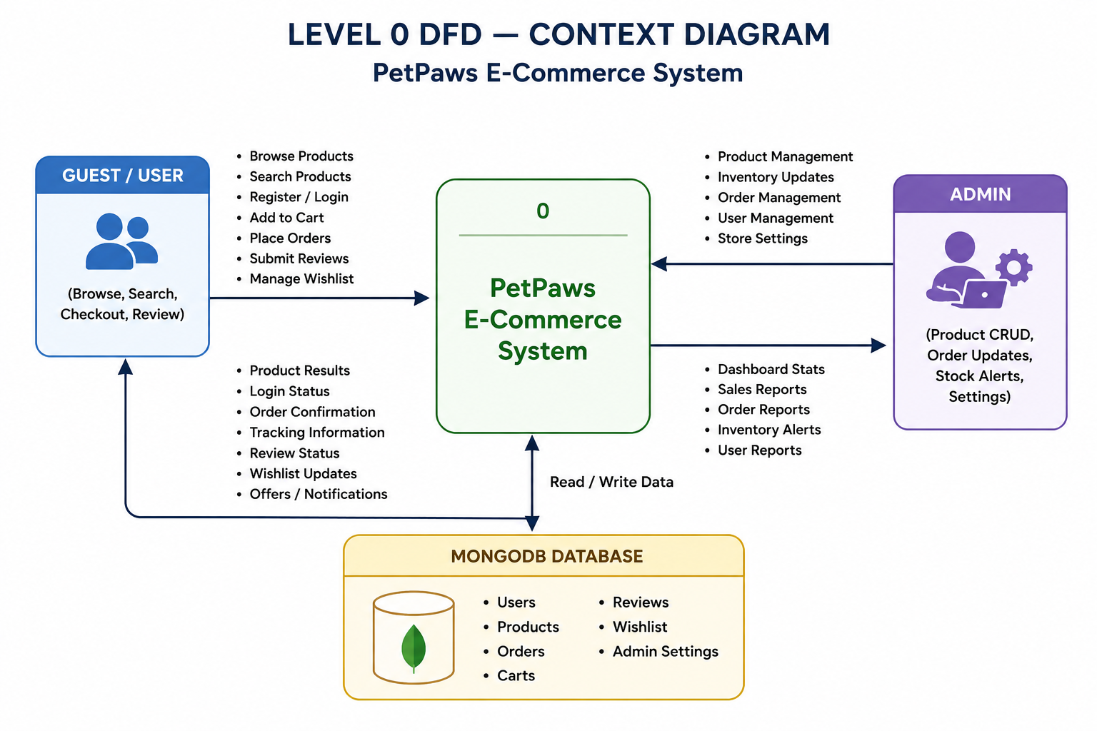

Level 1 DFD — Decomposed Processes

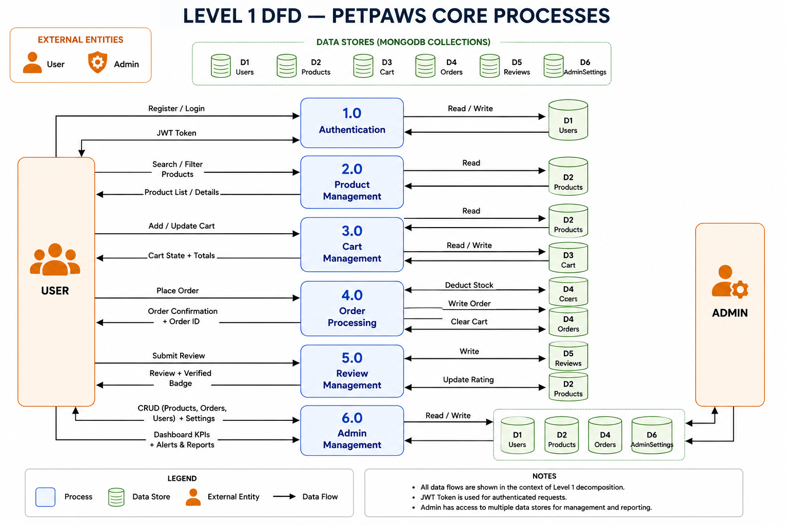

Mermaid Sequence Diagram — Cart to Order Flow
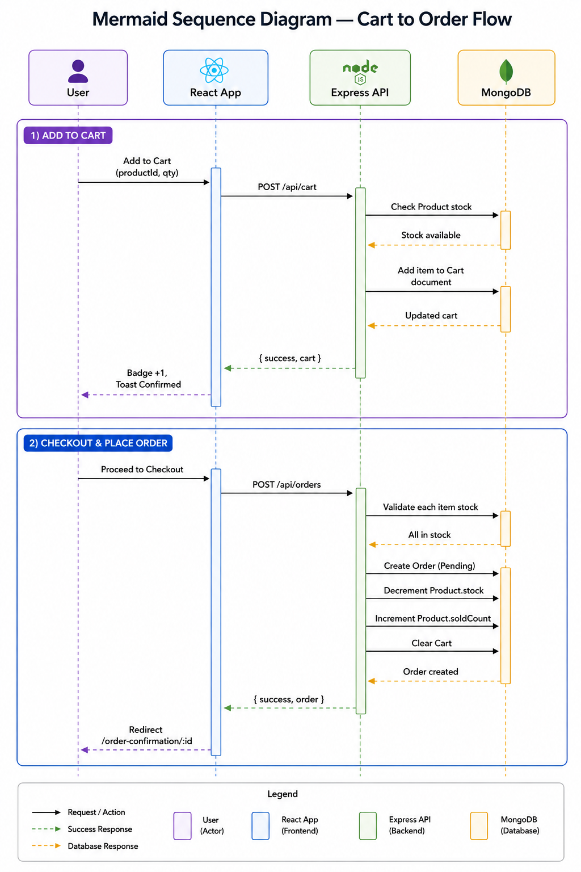

User Stories
User Type | Epic | USN | User Story | Acceptance Criteria | Priority | Release
Customer | Registration & Login | USN-1 | As a user, I can register by entering my username, email, and password | Account is created; JWT returned; user redirected to homepage | High | Sprint-1
 |  | USN-2 | As a user, I can log in with email and password and receive a JWT token | JWT stored in localStorage; AuthContext updated; redirect to previous page | High | Sprint-1
 | Product Browsing | USN-3 | As a user, I can browse all pet products with category and pet-type filters | Product grid renders with applied filters; total count displayed; pagination works | High | Sprint-1
 |  | USN-4 | As a user, I can search products by keyword and sort by price/rating/newest | Results update on search/sort; empty state shown when no results | High | Sprint-1
 |  | USN-5 | As a user, I can view a product detail page with images, variants, and reviews | Image gallery renders; variant buttons appear; reviews tab shows ratings | High | Sprint-1
 | Cart & Wishlist | USN-6 | As a user, I can add products to my cart and see a real-time cart badge | Cart badge increments; item persisted to MongoDB; toast confirmation shown | High | Sprint-1
 |  | USN-7 | As a user, I can add products to a wishlist and move them to the cart | Wishlist page shows saved products; move-to-cart clears item from wishlist | Medium | Sprint-2
 | Checkout | USN-8 | As a user, I can complete a 3-step checkout: address, payment, review | All 3 steps navigable; order placed on Step 3 confirm; redirected to confirmation page | High | Sprint-2
 |  | USN-9 | As a user, I can select saved addresses or enter a new address at checkout | Saved addresses shown as quick-select buttons; new address form validates all required fields | High | Sprint-2
 | Order Management | USN-10 | As a user, I can view my order history and filter by status | Order list renders with status badges; filter tabs change displayed orders | High | Sprint-2
 |  | USN-11 | As a user, I can track my order status via a visual timeline and cancel eligible orders | 5-stage timeline shown; Cancel button visible only for Pending/Confirmed; stock restored on cancel | High | Sprint-2
 | Reviews & Profile | USN-12 | As a user, I can submit a star rating and review for a product I purchased | Review appears on product page; Verified Purchase badge shown for delivered orders; rating average updates | Medium | Sprint-3
 |  | USN-13 | As a user, I can update my profile, change password, and manage addresses | Profile tab saves name/phone; password tab validates current password; address CRUD works correctly | Medium | Sprint-3
Administrator | Dashboard | USN-14 | As an admin, I can view KPI cards, revenue chart, low-stock alerts, and top products | Dashboard renders 4 KPI cards; bar chart shows monthly revenue; low-stock table shows items < 10 units | High | Sprint-3
 | Product CRUD | USN-15 | As an admin, I can create, edit, and soft-delete pet products | Product appears in listing after creation; edit form pre-populates; soft-delete hides product from customers | High | Sprint-1
 | Order Management | USN-16 | As an admin, I can update order status and add tracking numbers | Status dropdown updates order; tracking number visible to customer; statusHistory entry created | High | Sprint-3
 | Customer Management | USN-17 | As an admin, I can search customers and activate/deactivate accounts | Search returns filtered results; toggle changes isActive; deactivated user cannot log in | Medium | Sprint-4
 | Store Settings | USN-18 | As an admin, I can configure shipping fee, tax rate, and homepage banners | Settings saved and reflected immediately in checkout totals and homepage carousel | Medium | Sprint-4

